**s o f i a**

**Development Summary**

*Summary of Software Implementation Methods*

**Document Control**

|  |  |  |
| --- | --- | --- |
| **Editor** | **Date** | **Update** |
| **Daniel Berhe** | **12/03/2015** | **Created document** |
| **Alex Cash** | **12/03/2015** | **Added information pointing to the implementation planning spreadsheet** |

**Table of Contents**

1.0 Implementation Report 4

**­Implementation Report**

The first iteration development of the TeachEasy and LearnEasy applications was divided into smaller tasks based on the modules in the Software Design Diagram (Figure 1). These individual tasks were delegated to members of the development team. Our company uses an online repository (GitHub) to manage the development process. Issues are entered into the repositories issue tracking system to represent the individual tasks. Upon completion of a particular task, a pull request is generation by the person responsible. The completed task is then reviewed by the Lead Software Developer, the Specialist Software Developer or the Project Manager to check that the code looks reasonable and conforms to the company standard, which includes things such as comments and variable names. If the completed task conforms to the company standards, it is then merged to the master branch. This method aids in version control, minimising code loss and consistency. Testing of the completed code modules is organised by the Lead Software Tester to verify correct functionality. If a bug is discovered, it is recorded and reported to the person responsib­­­le for t­­­he completed task by means of the issue tracking system. The modules implemented so far have been highlighted in Figure 1. A full size version of the Software Design Diagram is available in the Software Design Specification folder.

Our company believes that the current software development process is appropriate in the development of TeachEasy and LearnEasy because software tasks are being developed in a timely manner and to a high standard.

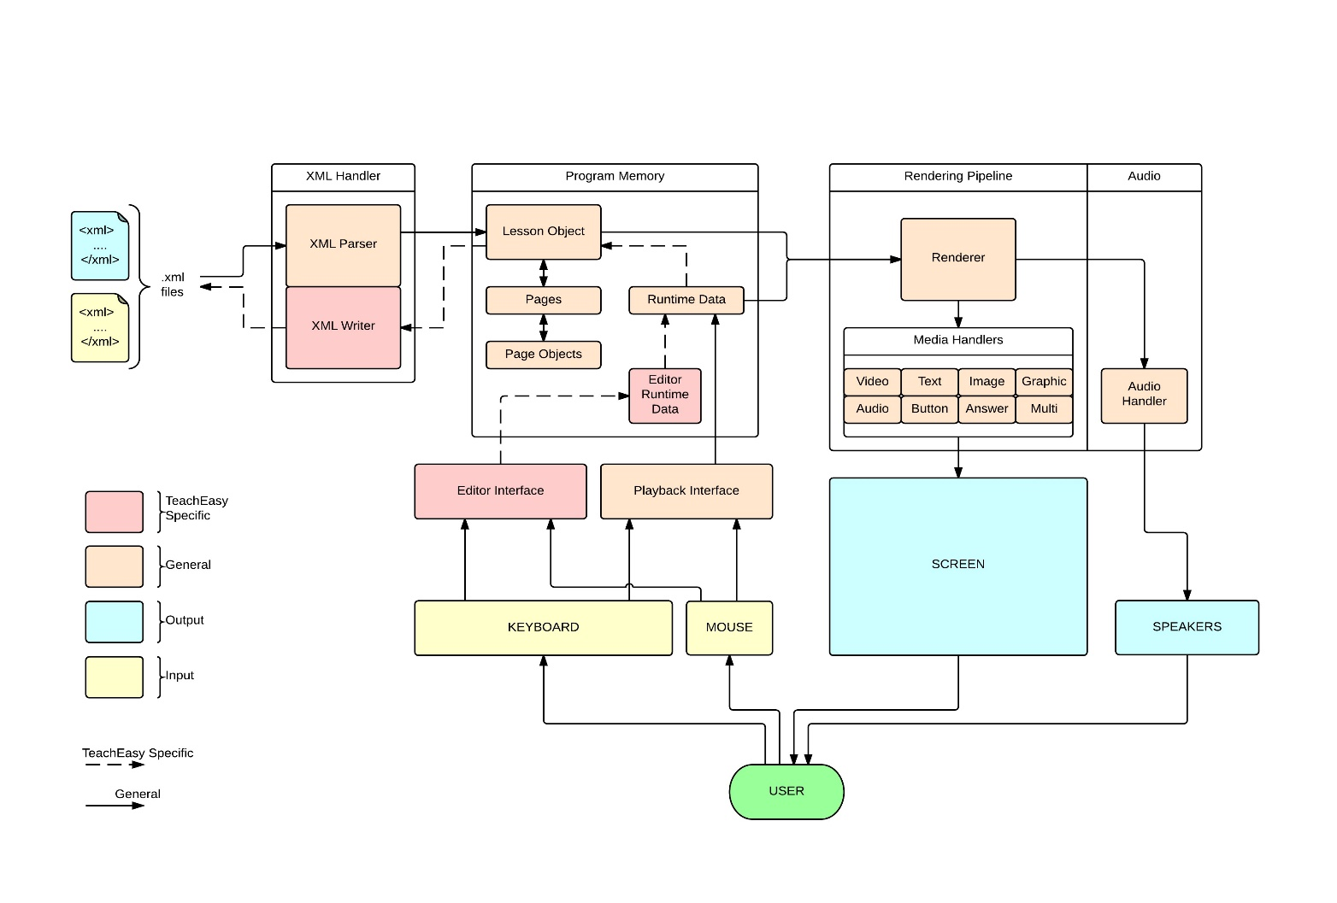

Figure 1: Software Design Diagram

For more detail on the specifics of the software please see the ‘Software Design Specification’ document, found in the folder of the same name. For information regarding current implementation progress and task breakdowns, please refer to the ‘Implementation Planning Spreadsheet’ in the ‘Release Planning’ folder.